Lab 4 CCS3101
25 April 2025
- Solve the following question and demonstrate your solution to me in this lab (preferred) or at the start of the next lab. For record-keeping, submit also your solution and screenshots of its output to PutraBlast.
- Evaluation will be done according to the lab rubric on PutraBlast. I will ask questions accordingly.
*******************************

Question:

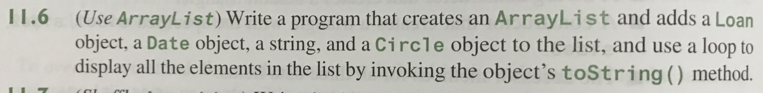

(The question is from the 11th edition of the Liang textbook.)

